**Normalization**

It is a technique to remove or reduce redundancy in a table.

**Row-level Duplicacy:**

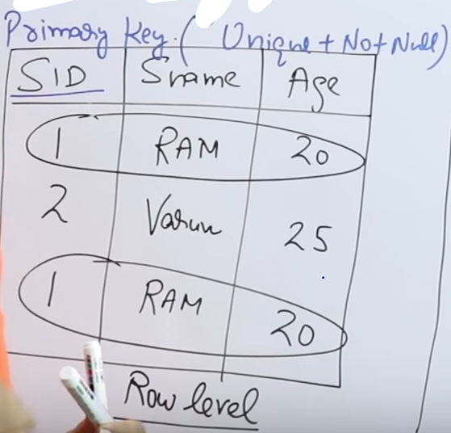

**Column-level Duplicacy:**

1. Insertion Anomaly
2. Deletion Anomaly
3. Updation Anomaly

Main-table



**Insertion Anomaly:**  
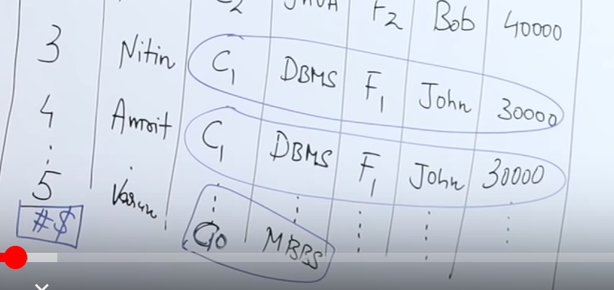

Inserting MBBS student’s data into the table. (Ir-relevant)

**Deletion Anomaly :**  
Delete from student where SID =2  
  
Now SID are discontinuous

**Updation Anomaly:**  
Updating F1’s salary from 30,000 to 40,000  
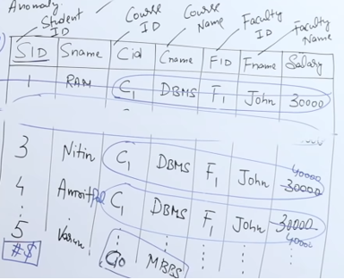  
Each and every where the F1 employ is present the salary is updated.

**Solution:**



**1st Normal Form**

**“** A relation is in first normal form if and only if the [domain](https://en.wikipedia.org/wiki/Data_domain) of each [attribute](https://en.wikipedia.org/wiki/Column_(database)) contains only [atomic](https://en.wikipedia.org/wiki/First_normal_form#Atomicity) (indivisible) values, and the value of each attribute contains only a single value from that domain.**”**

If any multivalued and composite attributes are present, then that relational schema 🡪 Not in 1st Normal form.

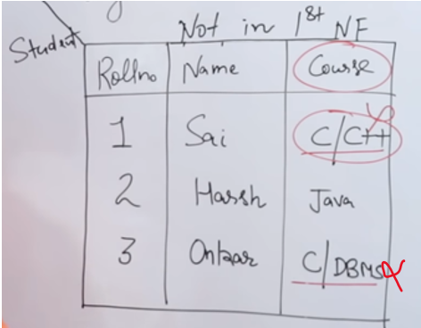

Here C/C++ and C/DBMS are multivalued attribute, so the table is not in 1st Normal Form.

**1st solution:**

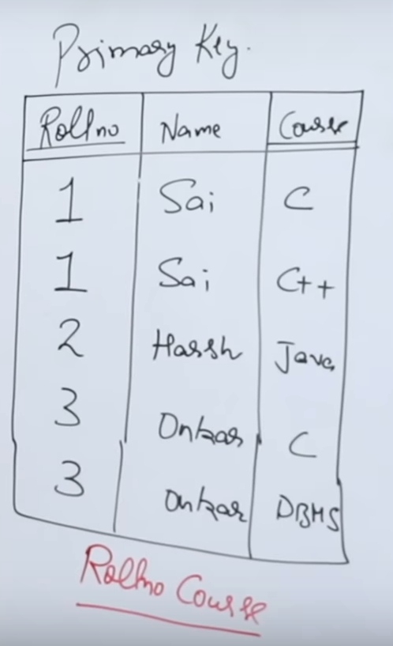  
Both (Rollno,course) 🡪 together is a primary key.

**2nd solution:**

Only Rollno is the primary key. There will be many NULL values if the student doesn’t take more courses.

**3rd Solution:**

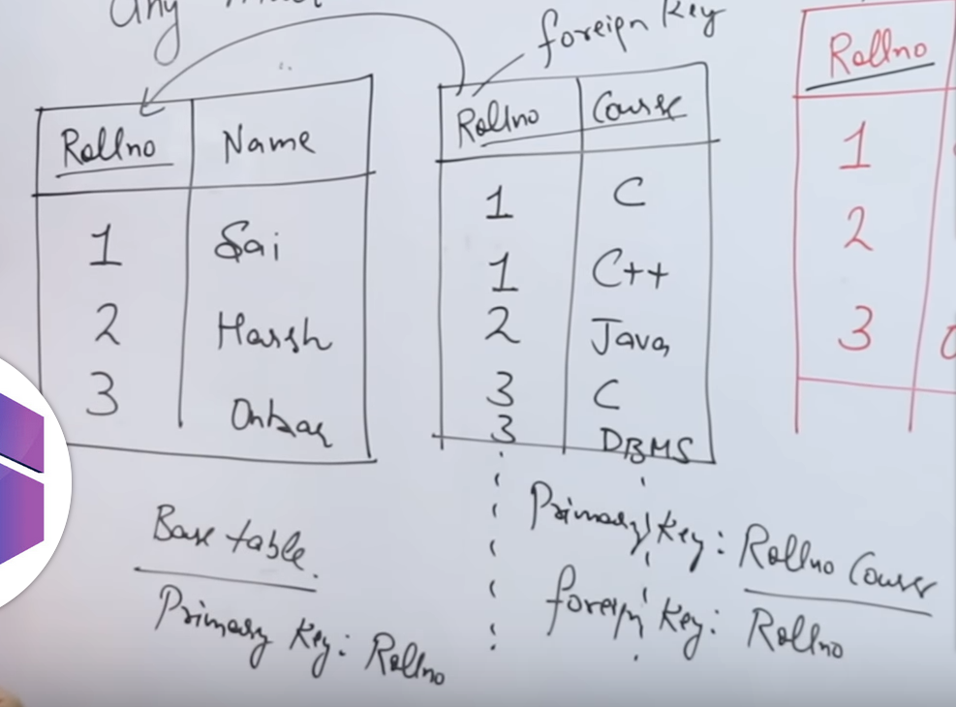



Base table 🡪 Roll number(primary key)  
Derived table 🡪Roll number(foreign key)   
 Roll number and course (primary key)

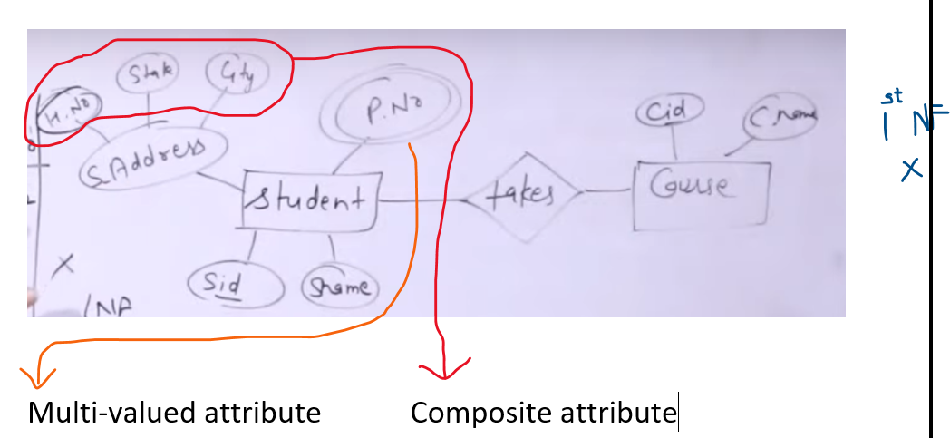

There are many ways to convert ER 🡪 Relation model





**Definition** : A relation is said to be in 1st normal form, if and only if all the attributes are having atomic domains.

**1)Atomic domains** 🡪 Cannot be further decomposed. Each cell should contain only one value.



Now the States have put into separate column, and only one phone number is included for every student.

**2) A column should contain values from the same domain.**

(i.e) A column should contain value of the same data type

  
No interchanging the values, if so data-types clashes



**3) Each column should have unique name.**

No two column name should be repeated.



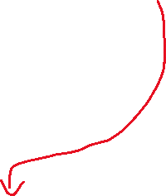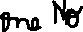

This should be not there

**4) No ordering to the rows and columns**

It is not necessary that the rows (top to bottom) should be in a specific order.  
Eg: Payal’s row can come to first 🡪 No issue.

It is not specific that the columns (left to right) should be in a specific order.  
Eg: 1st column Sname, 2nd column Sid

Entity relation diagram 🡪 Relational Model



When ever we convert the entity relationship diagram to relational model, then that relational model should be in 1st normal form. (Since composite attribute 🡪 separate columns  
and multivalued attribute 🡪separate tabel)   
If the relational model 🡪 Not in 1st normal form, then that ER model is not designed properly by the data-base designer.

If we want a required a specific normal form, then we want to make changes only in the ER model and then convert.

So modification must be done only in ER-model and not in relation model.





The above table is also in 1st normal form. This is in Many to one relationship.







Here for Sid 🡪 1 there are two phone numbers. Here in Phone1 and Phone2 column, there can be P2,P1 (phone numbers can be interchanged) . Some will not have two phone numbers.

Ans : The best Relation model 🡪 2nd one  
Composite attribute 🡪 Separate columns  
Multivalued attribute 🡪 Separate tables (linking is must)



**Finding closure of Functional Dependency**

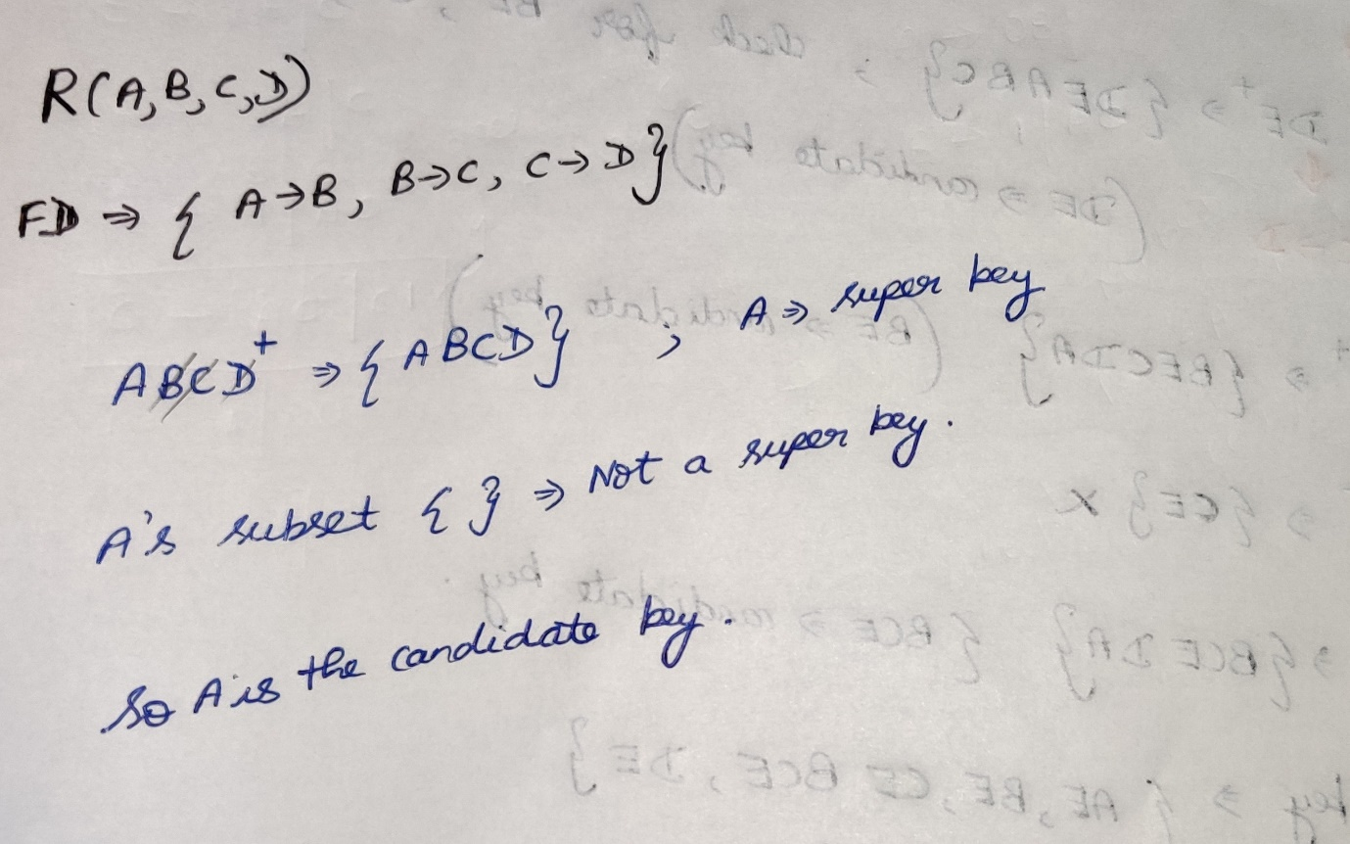

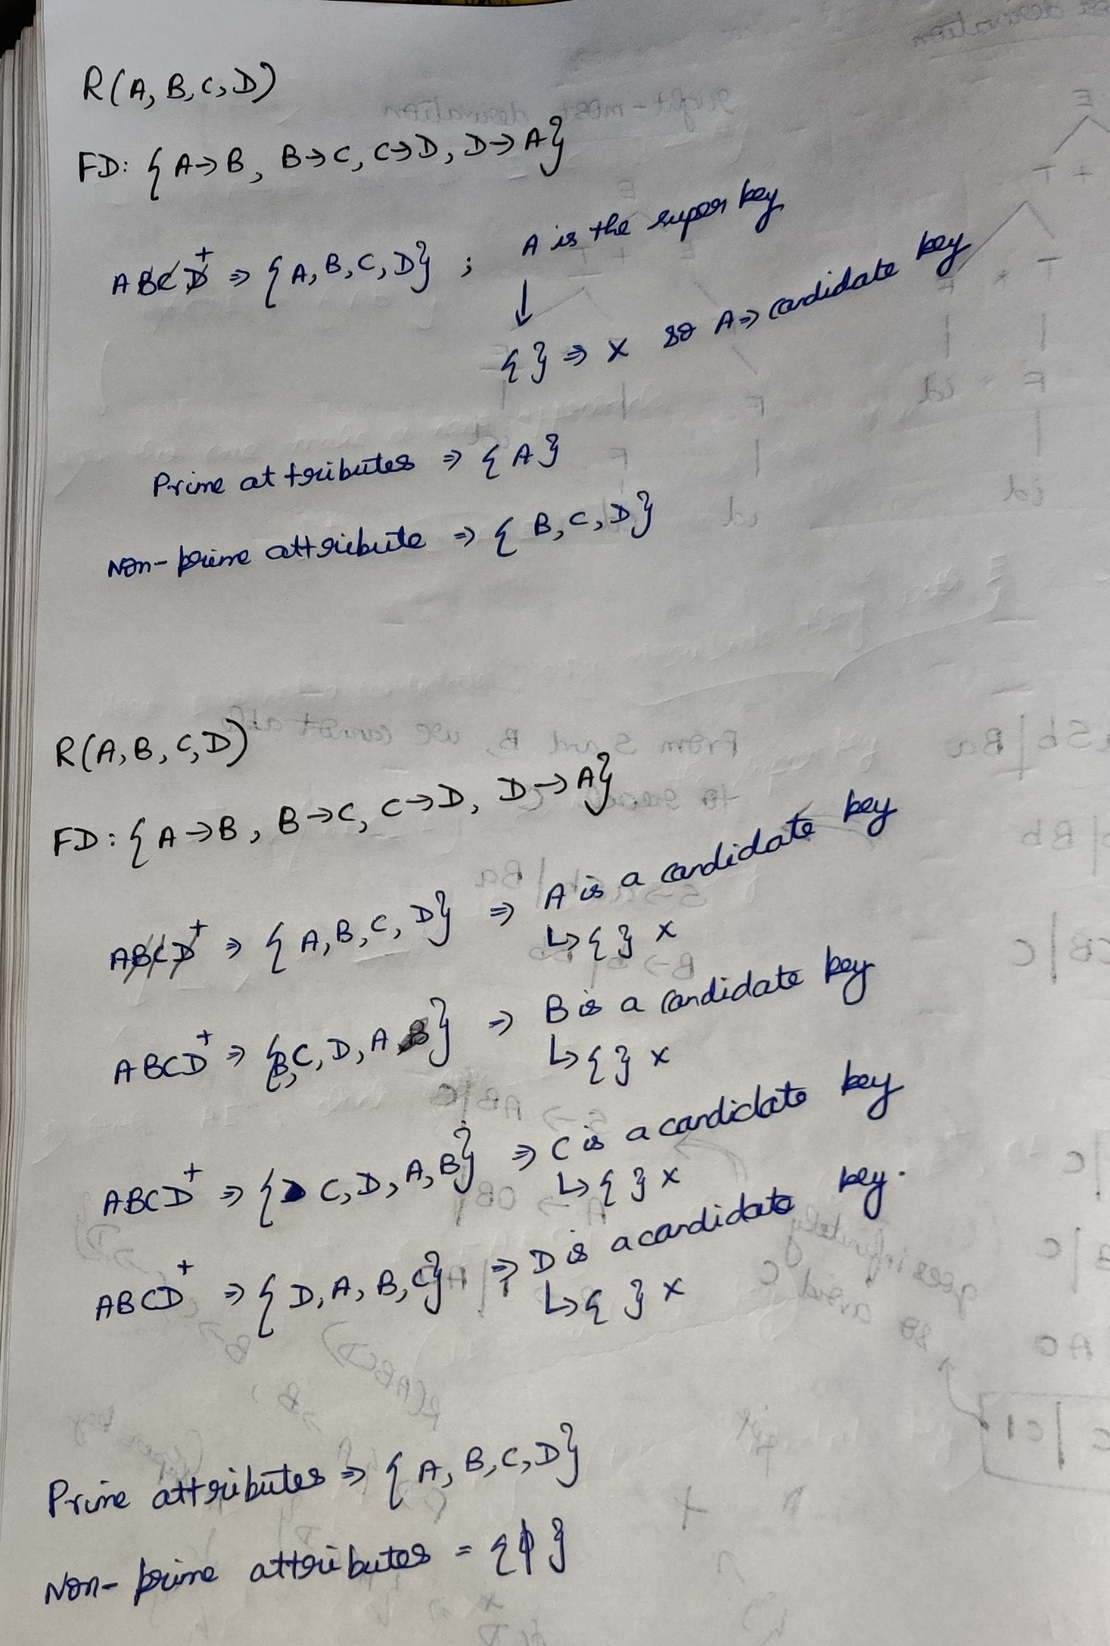

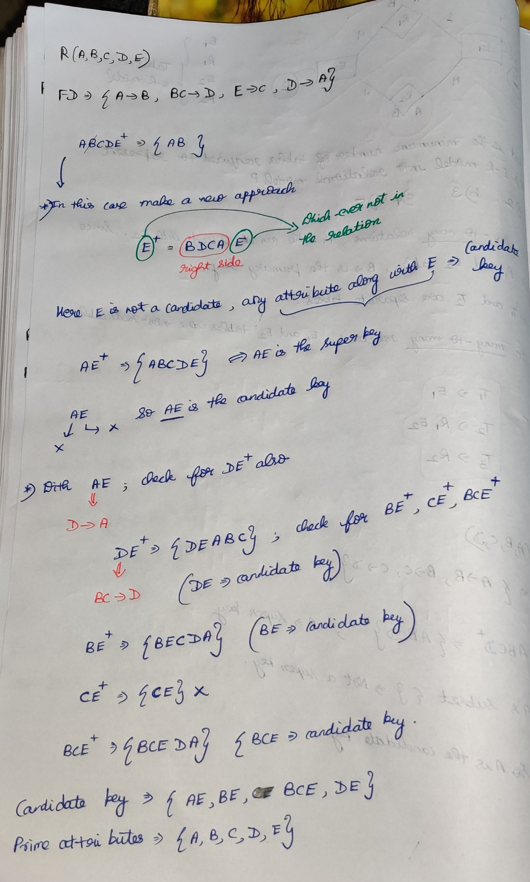

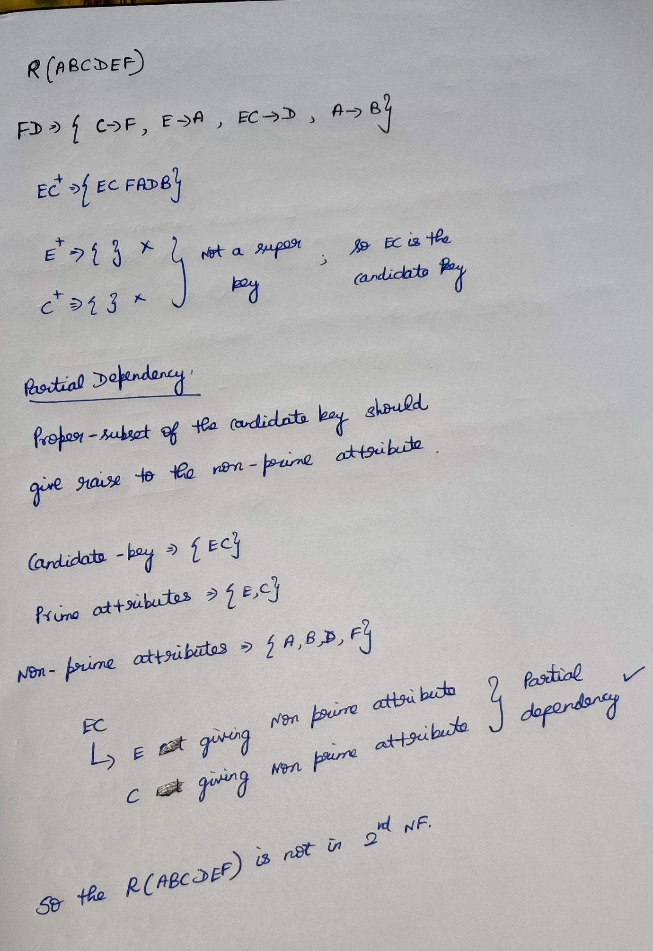

**2nd Normal Form**

***The relation is said to be in 2nd normal form if and only if***

***1)The relation is in 1st normal form.  
2) All the non-prime attributes should be fully functionally dependent on the candidate key.***\* No partial dependency in the relation.

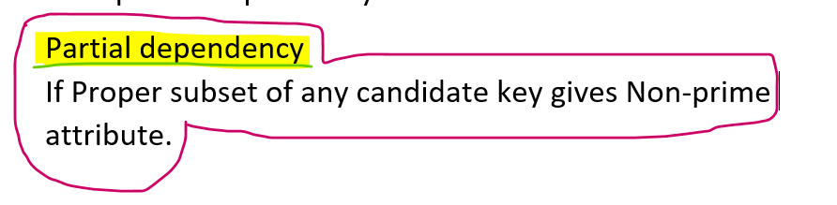

Prime attributes 🡪Attributes which are part of candidate key  
Non Prime attributes 🡪Attributes which are not the part of candidate key

**Shortcut method:**

* ***Left hand side must be a proper subset of Candidate key and***
* ***Right hand side is a Non-Prime attribute***

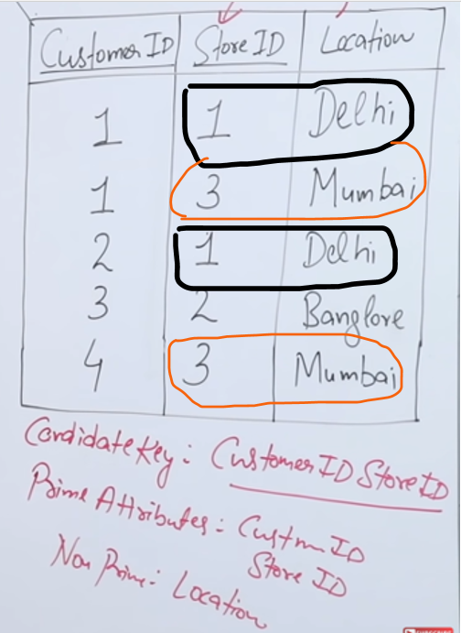

Candidate key 🡪 {customer-id,store-id}

Prime attributes 🡪 {customer-id,store-id}  
Non-prime attribute 🡪 {location}  
***Partial Dependency 🡪 Proper set of the candidate key determines the non-prime attribute***  
Here Location is determined by the store id (i.e store id 🡪 location). So not in 2nd Normal Form.

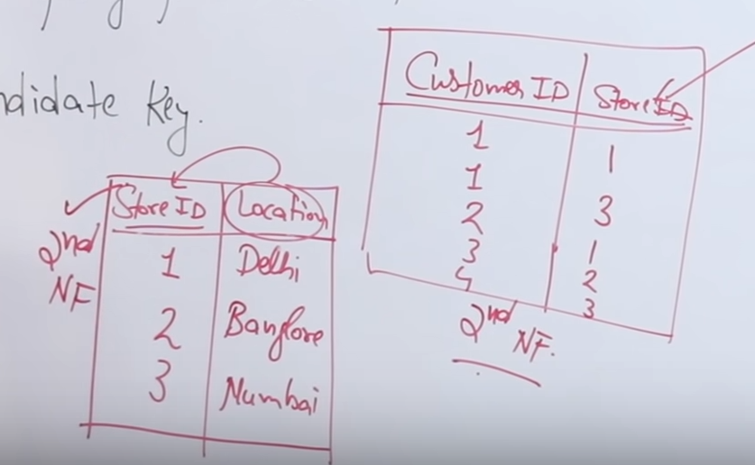

Candidate key 🡪 Store_id   
Prime attributes 🡪 Store_id  
Non Prime attributes 🡪Location

***Partial Dependency 🡪 Proper Set of the candidate key determines the non-prime attribute***  
{ Null } gives nothing.   
So No partial dependency 🡪 2nd Normal Form



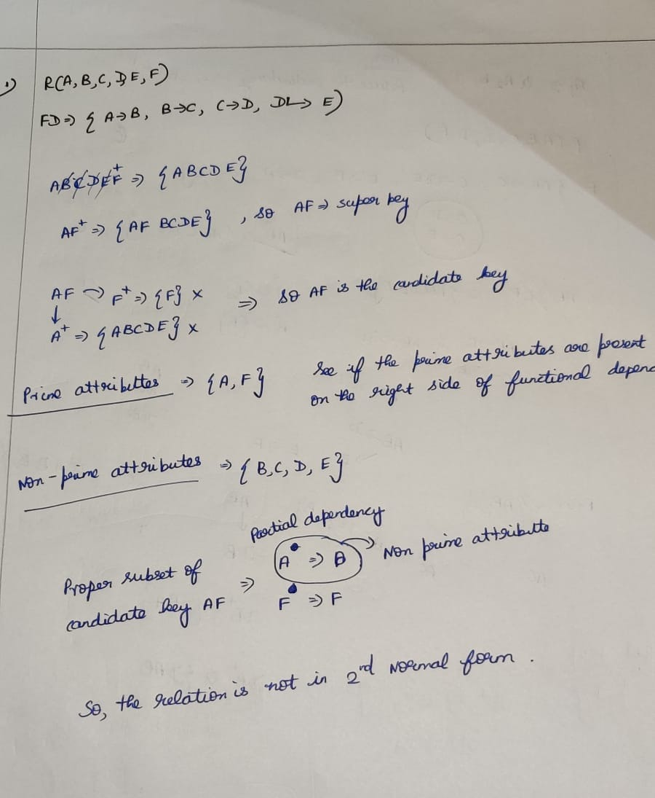

If all the attributes of a relation 🡪 Prime attributes then that relation will be definitely in 2nd normal form.

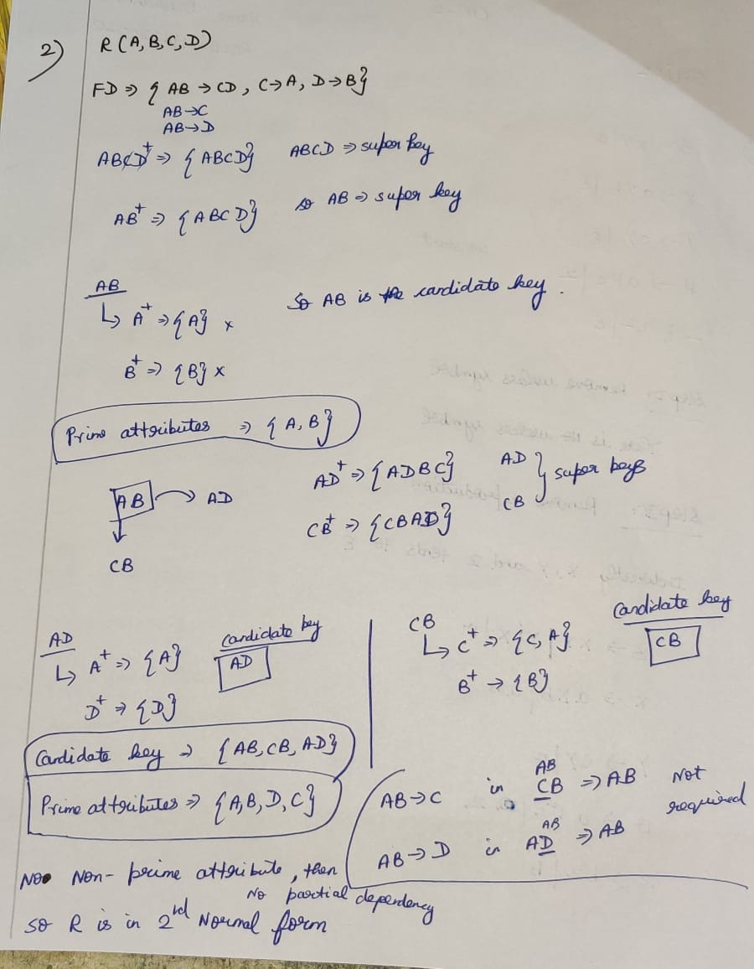

If there is 1 attribute in super key, then definitely that attribute will be the candidate key.

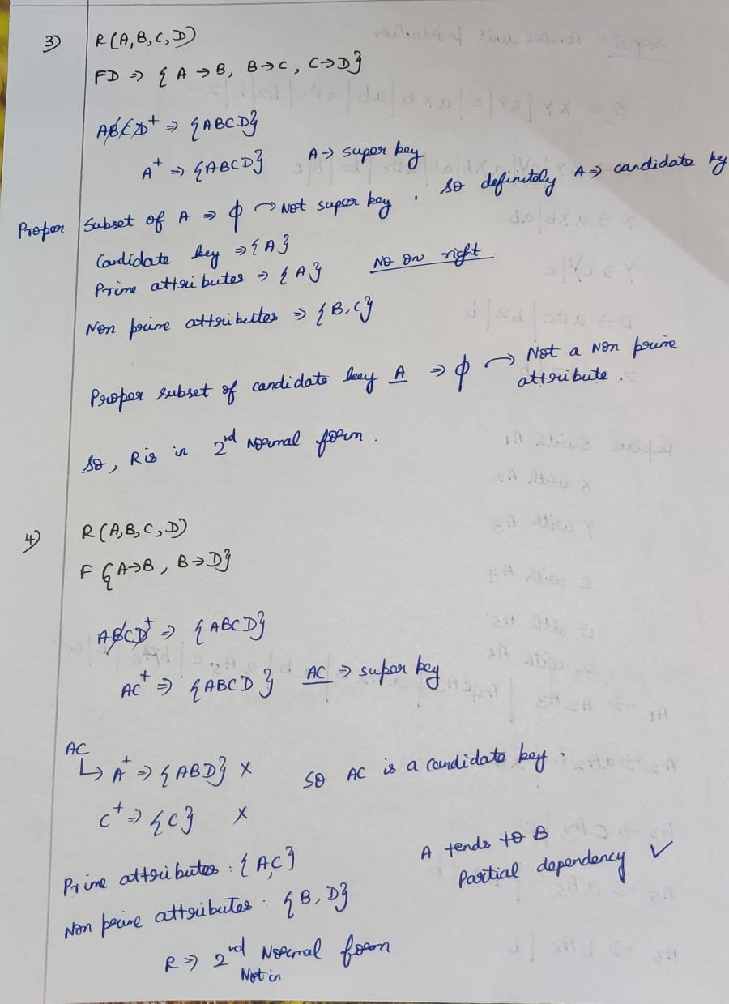

**3rd Normal Form**





**The above table 🡪 2nd Normal form, How????**  
Super_key 🡪 Sid.   
If Sid🡪candidate key, then definitely its proper subset must not be a super key.  
Sid’s proper subset is , So Sid🡪candidate key. No partial dependency so the table is in 2nd normal form.



**Although the table is in 2nd normal form, is it a good design?**



PinCode 🡪 State,Country. If I want to change the pin-code and state then definitely I want to change in all the rows, So update anomaly comes into the picture. Although it is in 2nd normal form update anomaly issue arises.

So the solution is to divide the table

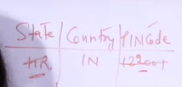

After dividing the table, once if I change the pin-code and state, that is enough. So update anomaly 🡪 removed.

So why the update anomaly problem comes, because of   
**PinCode 🡪 State,Country** [ Transitive dependency ]



NPA 🡪 Non Prime Attribute.

If a transitive dependency is in a table then it is not in 3rd Normal form.

***A relation is said to be in 3rd normal form if and only if***

* ***The relation is in 2nd Normal Form***
* ***There is no transitive dependency for non-prime attributes***

Transitive dependency   
Non-prime attribute 🡪 Non-prime attribute



If, prime attributes🡪Non-prime attributes Partial dependent  
then that is not in 2nd normal form itself.



A table is in 3rd Normal form if and only if for each of its non-trivial functional dependency (AB🡪C) at-least one of the following conditions holds good

**Shortcut method:**

* ***Left hand side must be a Super Key or Candidate key (or)***
* ***Right hand side is a Prime attribute***

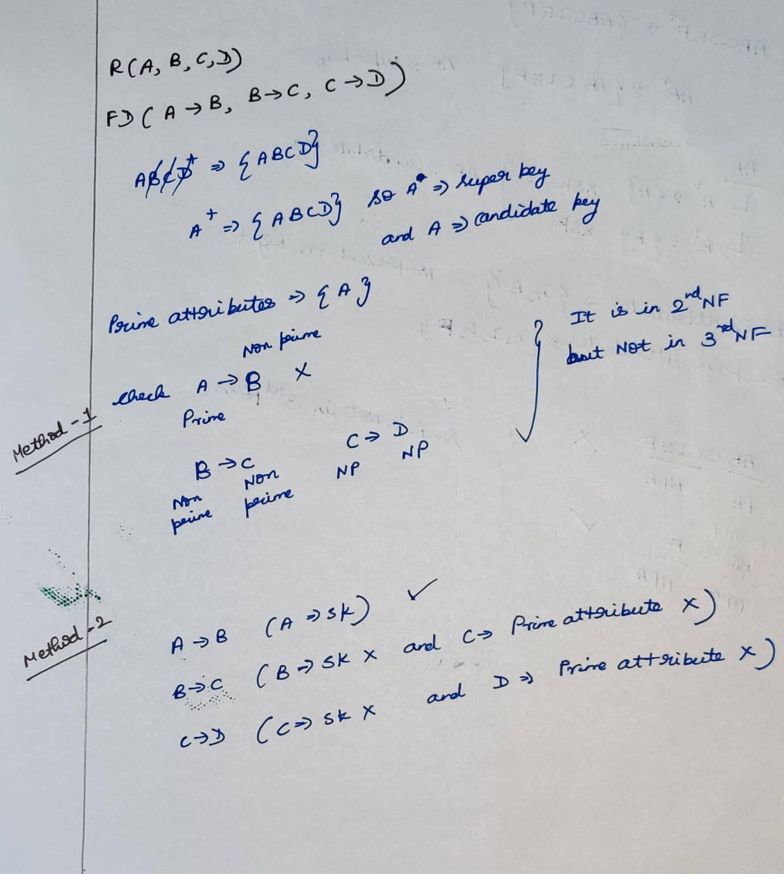



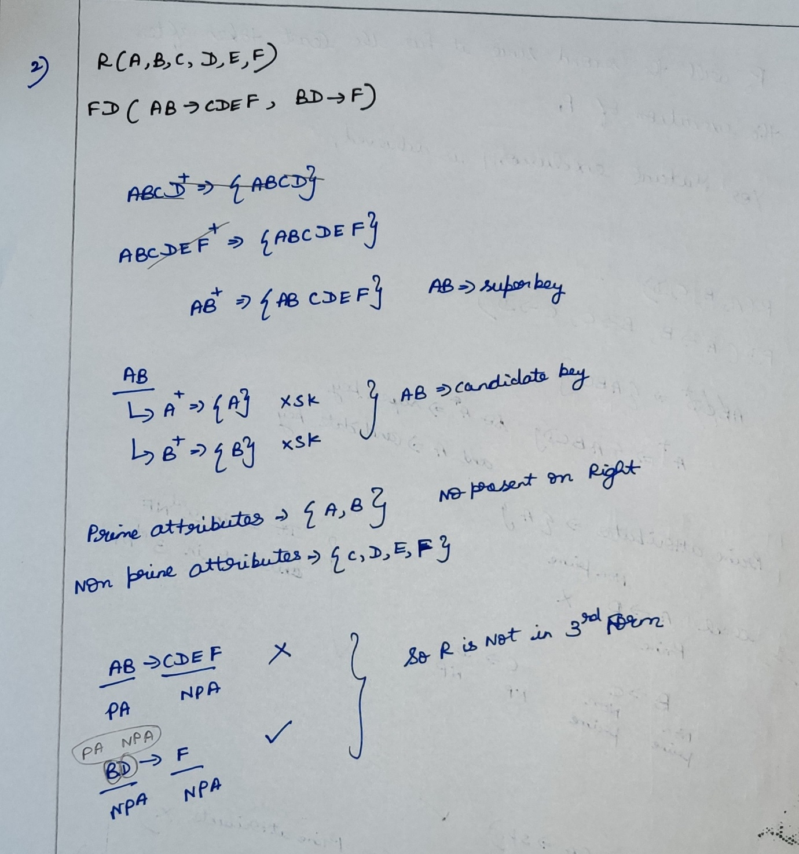



(Prime attribute)*(Non-prime attribute) 🡪 Non-prime attribute

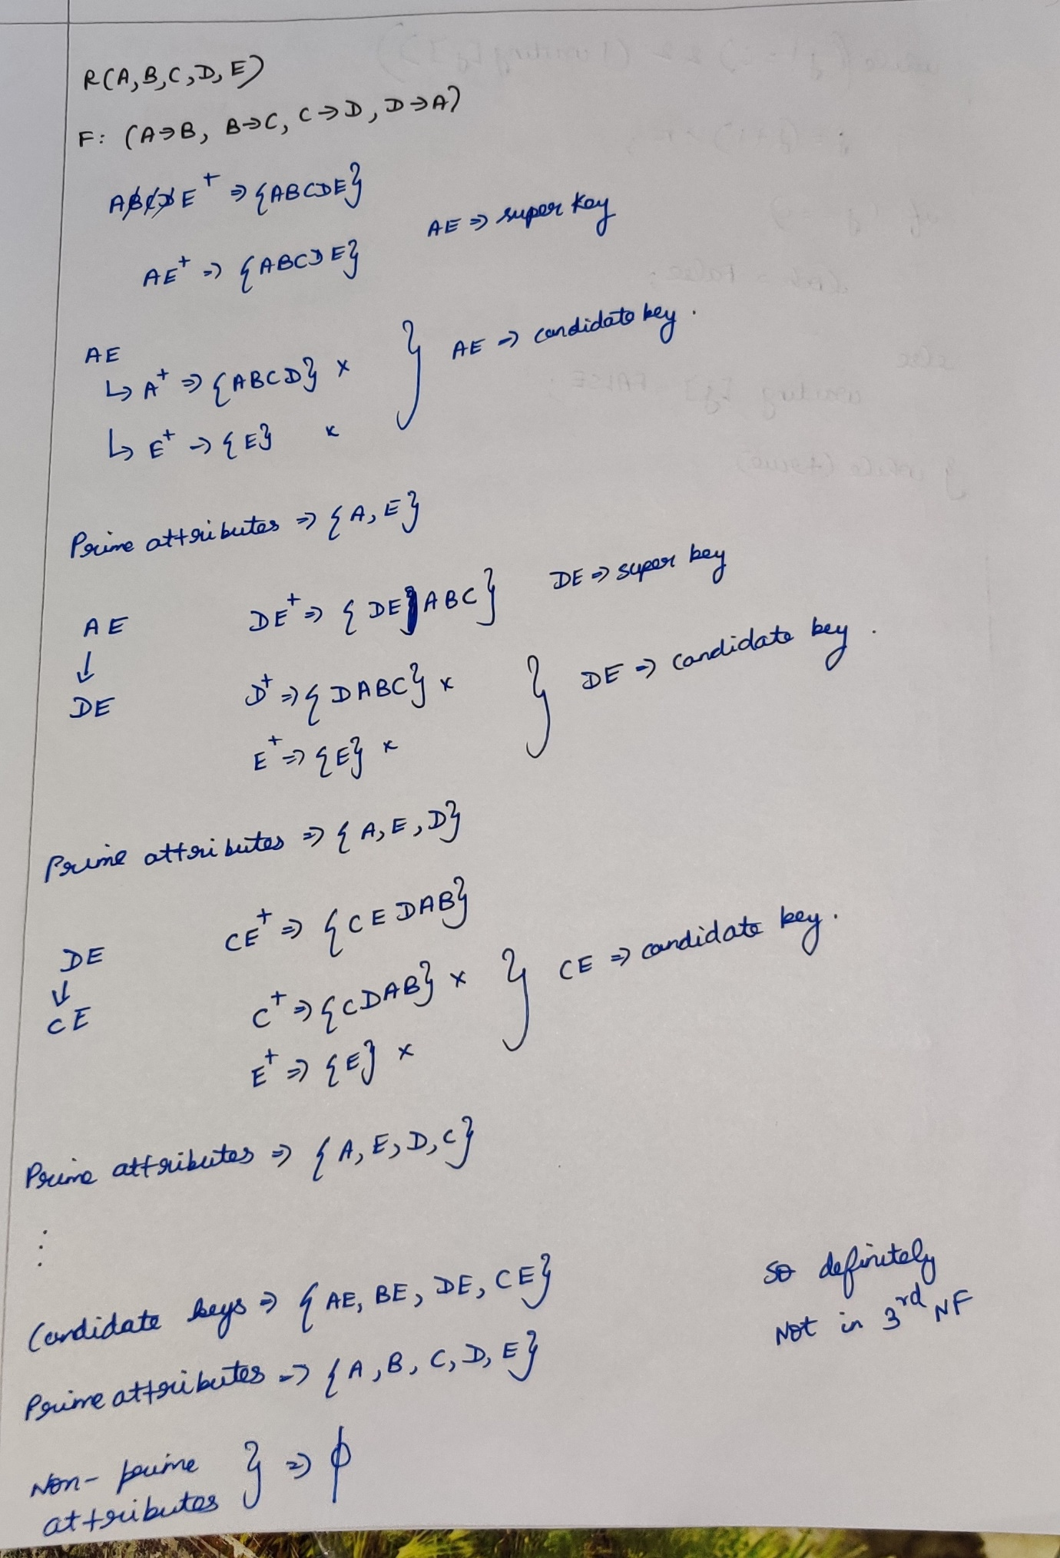



**Boyce Code Normal Form (BCNF)**

***A relation is said to be in BCNF if and only if***

* ***The relation should be in 3rd Normal form.***
* ***For each non-trivial functional dependency FD(X🡪Y) ,  
  the left side(i.e X) must be a super key.***

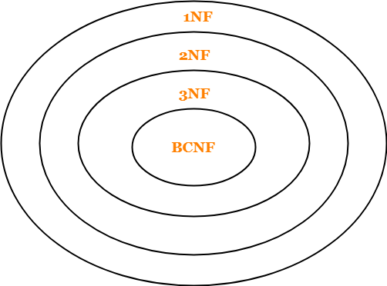

**Check the highest Normal form**

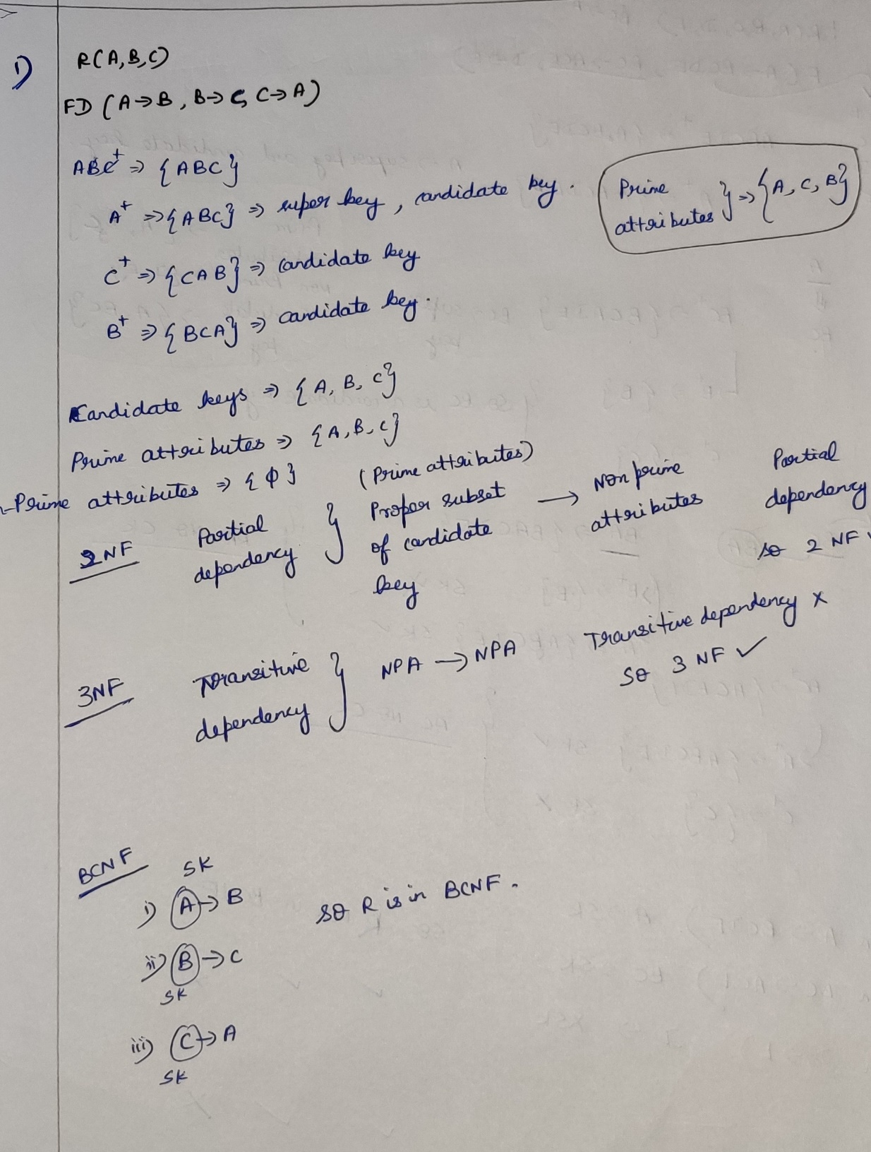



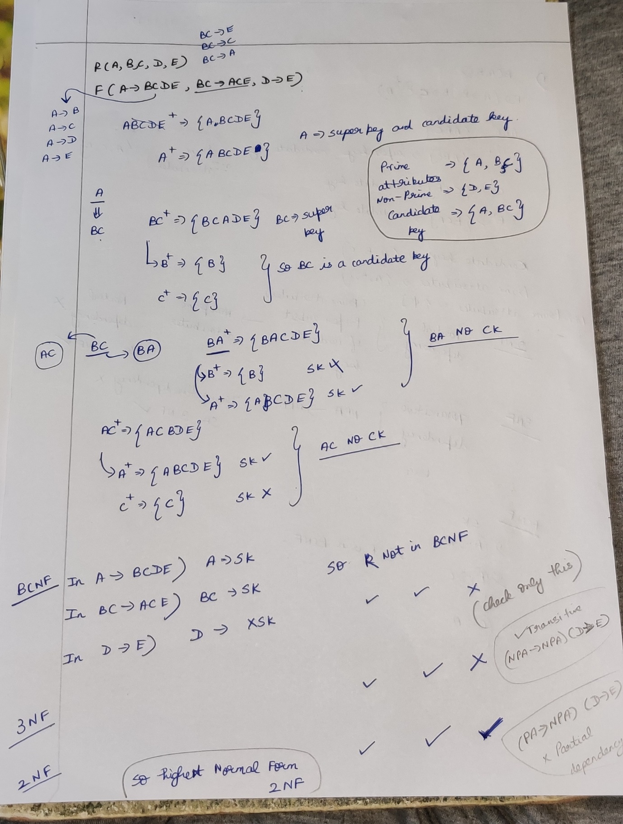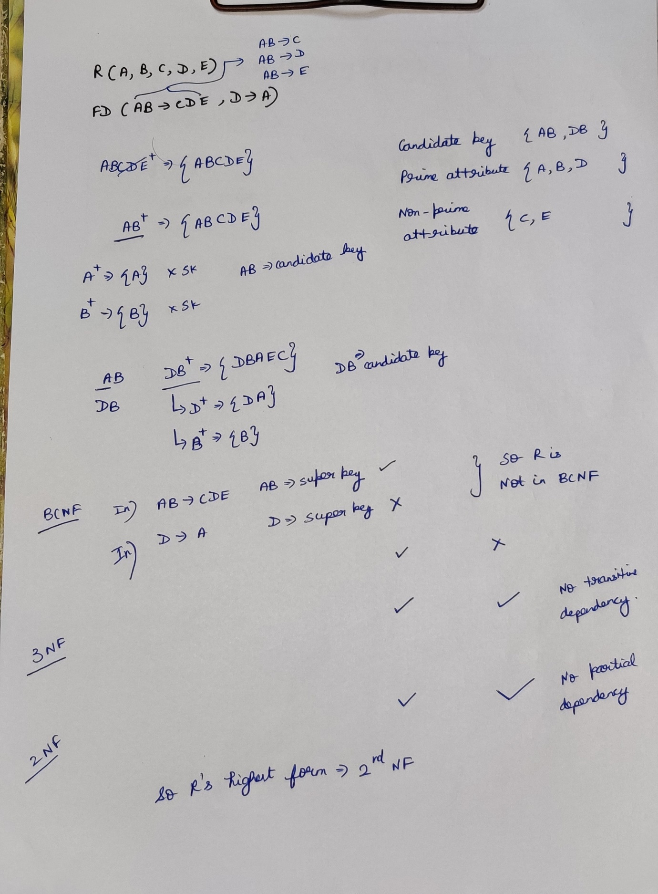

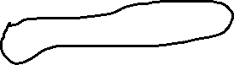

Example Sums

